***Project on Creating Vpcs, Subnets and Routers, and attaching the gate way for this vpcs***

**1. Prerequisites**

* AWS console

*  IAM

* VPCS

*  SUBNETS

**# ROUTERS**

**# INTERNET GATEWAYS**

**2. Create vpc to create that enter in to the aws console and navigate to vpc**

**a. After navigating the vpc and enter in to the vpc and select create vpc**

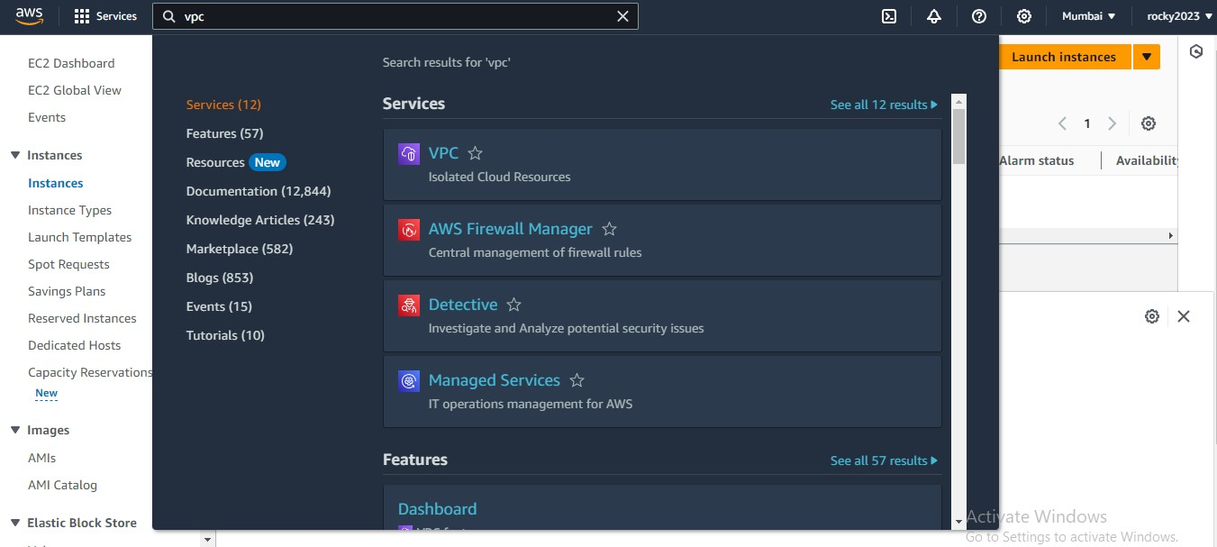

**3. Create vpc and add some requisites show below**

**a. Select vpc only**

**b. In cdr block select (ipv4 CIDR MANULA INPUT)**

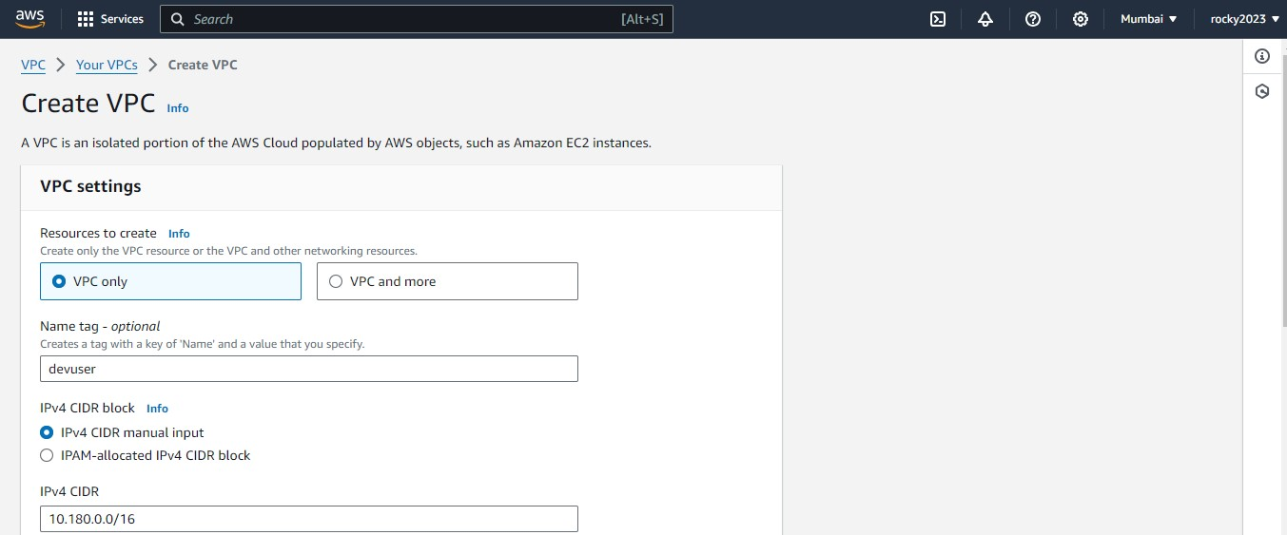

**4. After giving requisites select create vpc .**

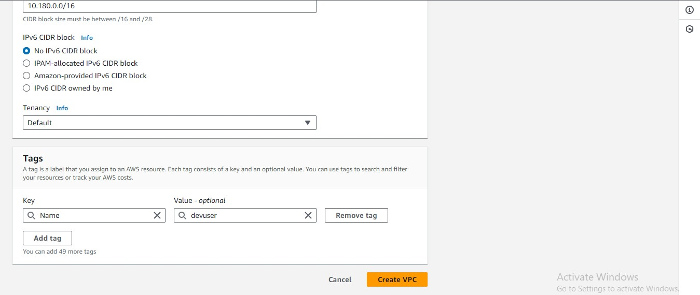

**5. Vpc created successfully and next go for creating igw (internet gate way)**

**To select igw it shows left side vpc list select their .**

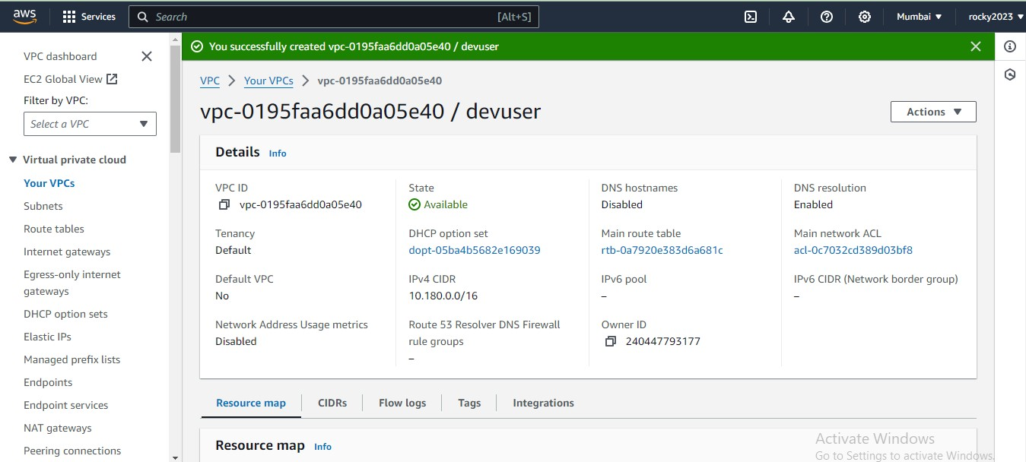

**6. Create internet gateway by selecting IGW .**

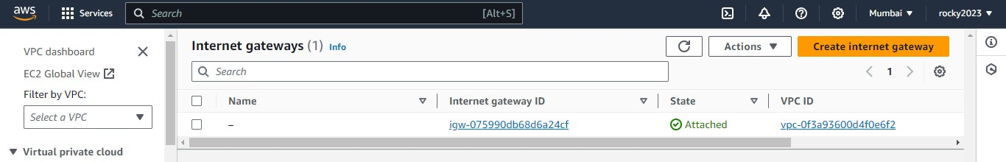

**7. Create Igw by adding some credentials.**

**a. Give tag name.**

**b.Next click on create internet gateway option.**

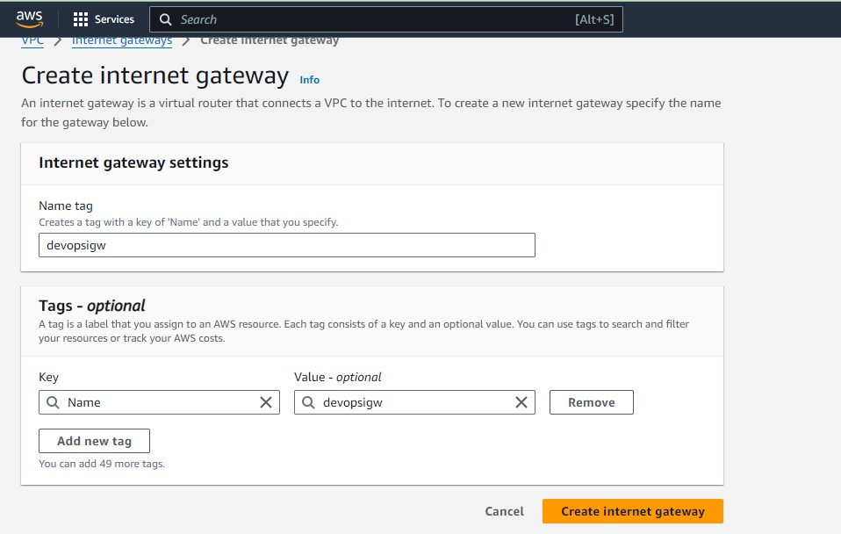

**8. After creating igw next attach to vpc it shows left side top .**

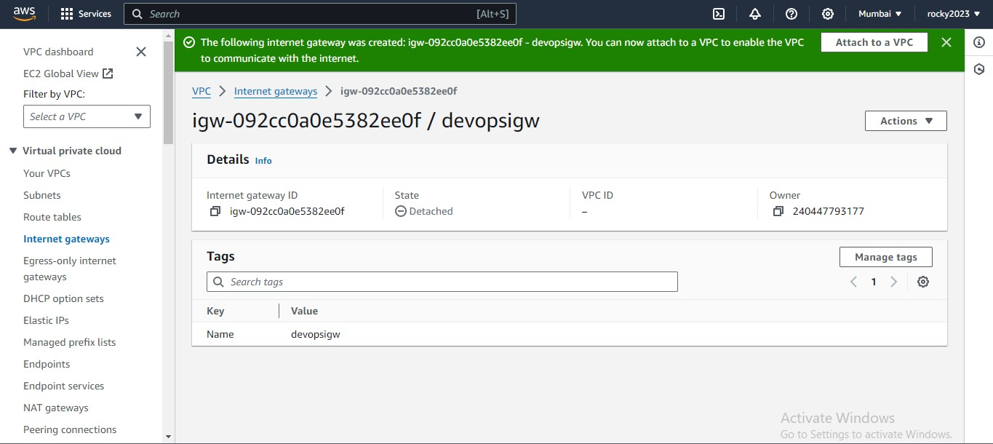

**9. Inside attach to vpc add ur created vpc by clicking on that box**

**a. Next click on attach internet gateway button.**

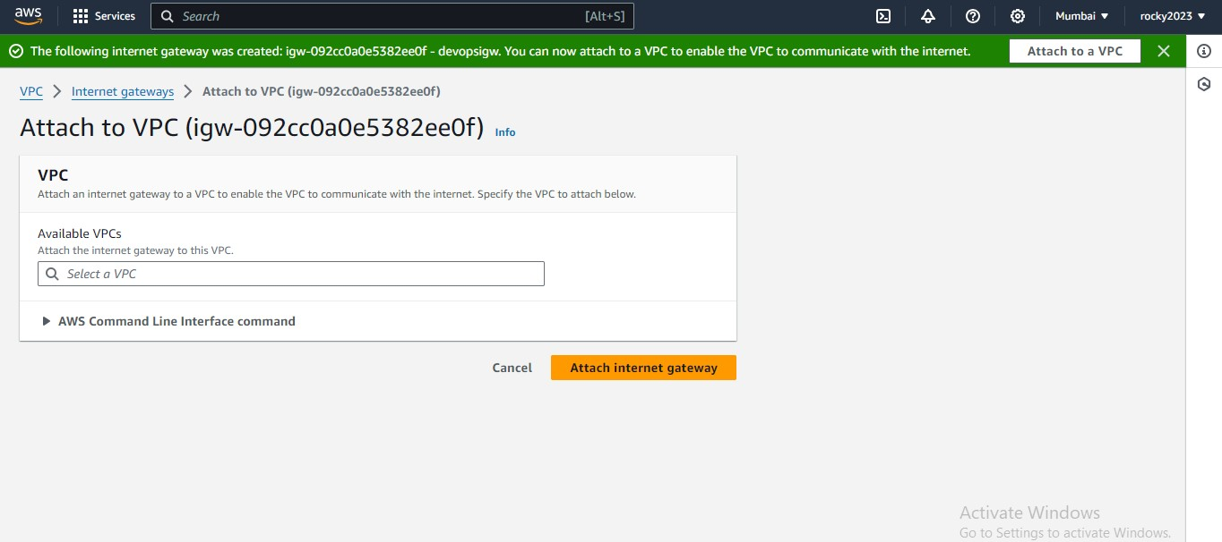

**10. Below imag shows clearly that igw attached to the vpc.**

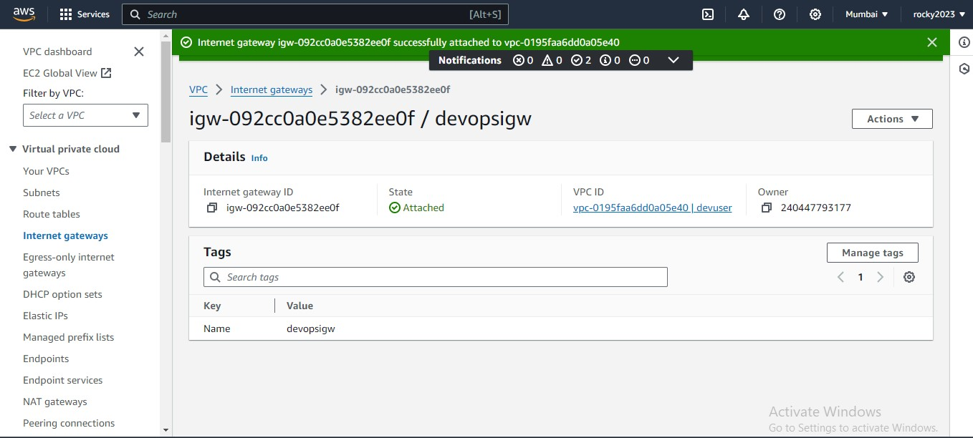

**11. Created subnets will show on left side of the vpc list.**

**a. Subnets for 2 Public and 2 private .**

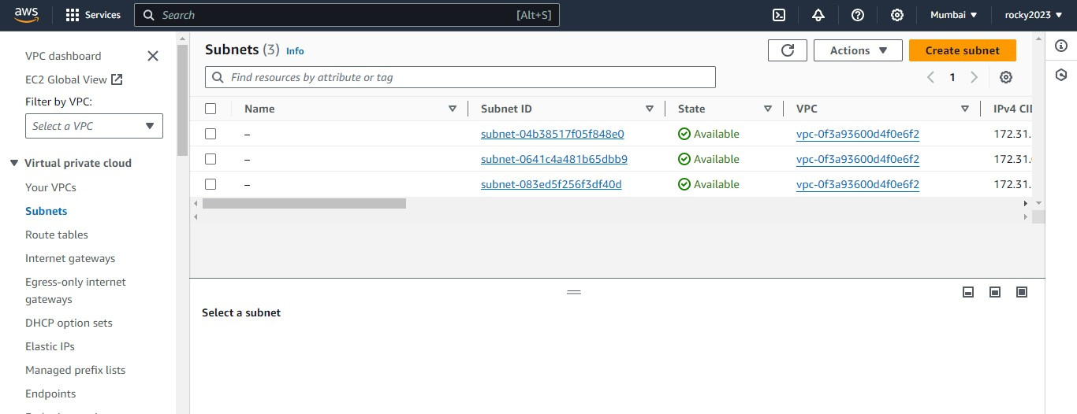

**12. Add credentials in that boxes as shown in below image.**

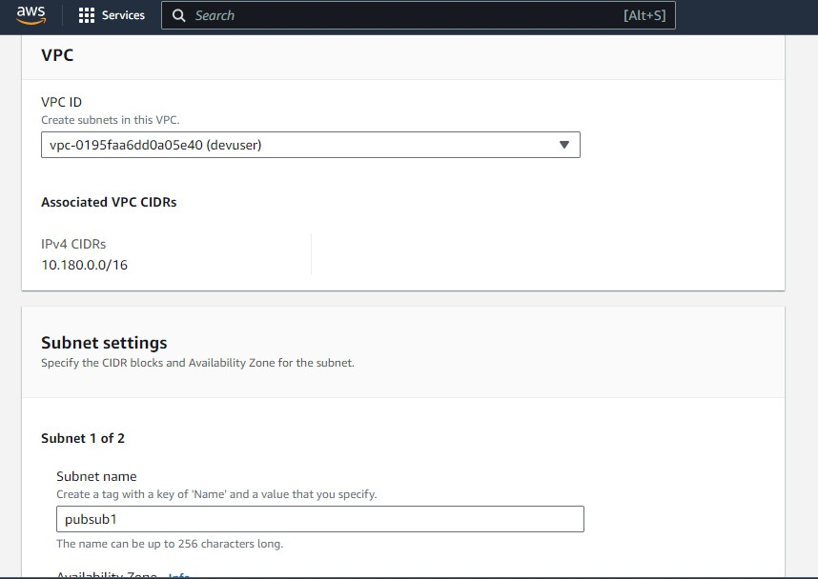

1. **Continued from the above image add credentials to end of the page.**

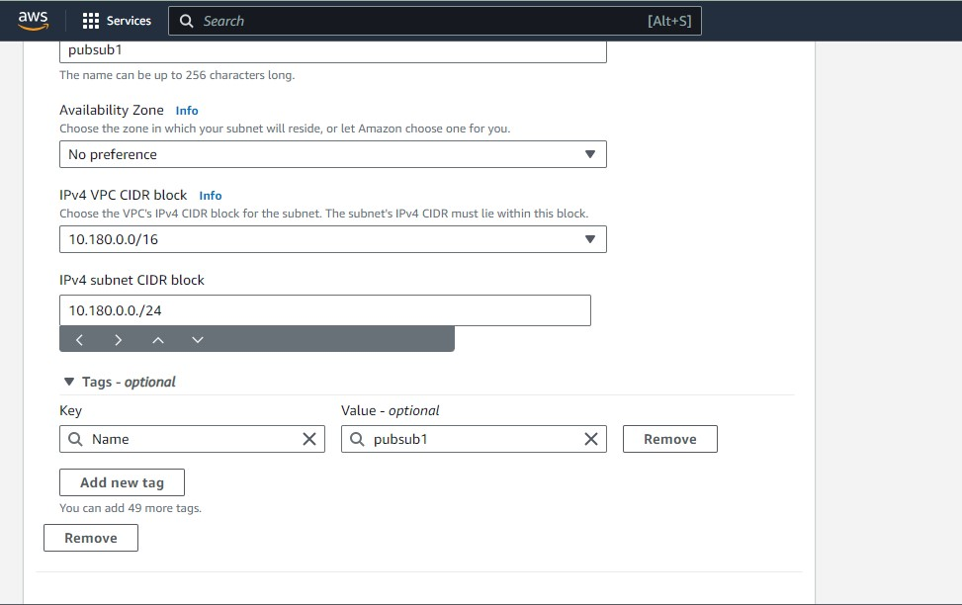

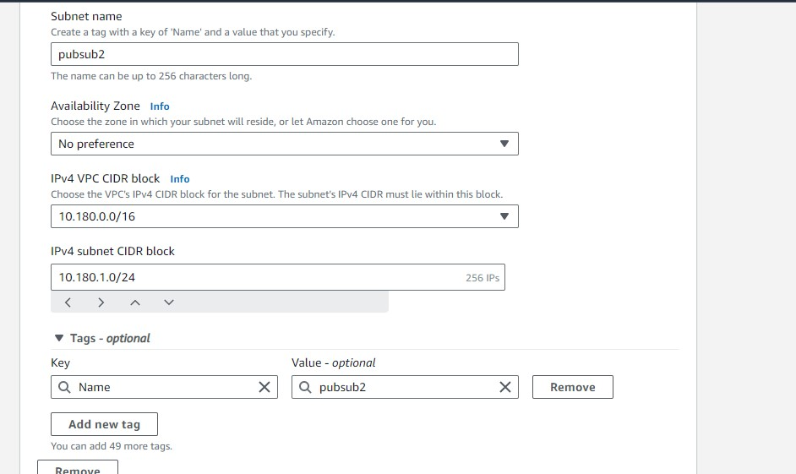

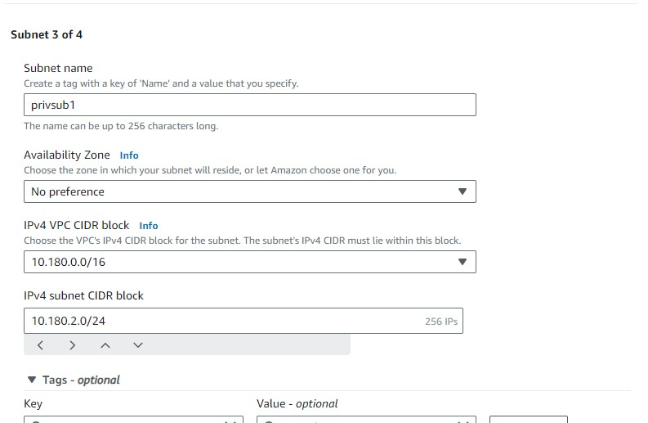

**13. Finally Subnets created**

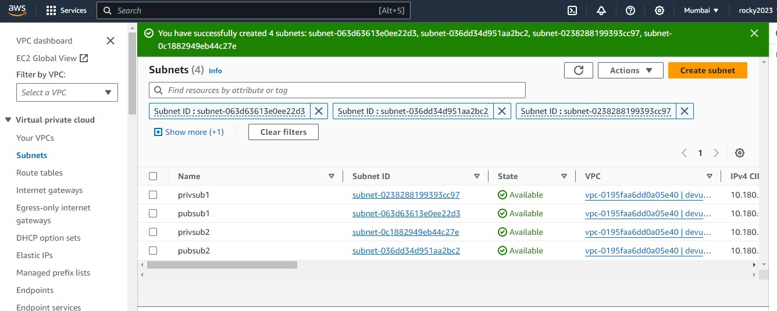



**14. Create route tables for public and private.**

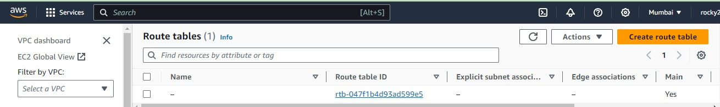

**15. After entering in to the route table add details for that as shown in below image.**

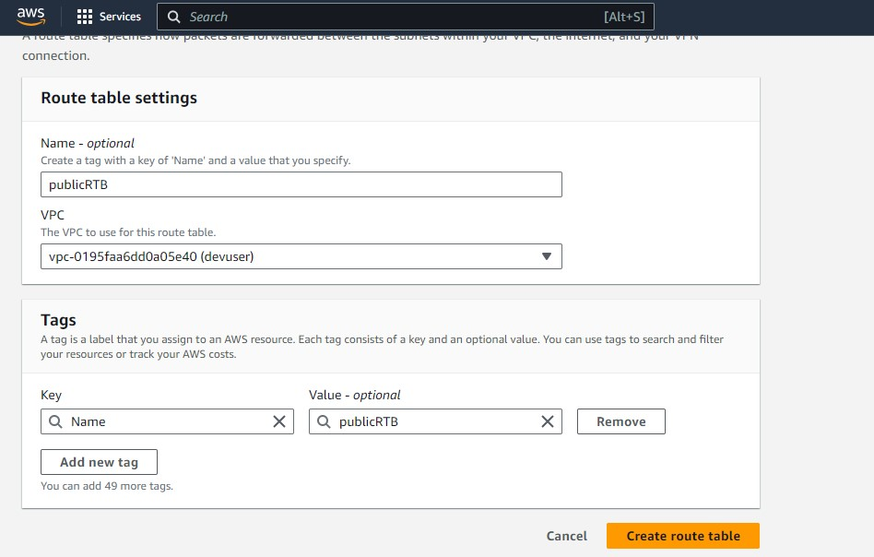

**16. Below image show succesfull creation of route tables.**

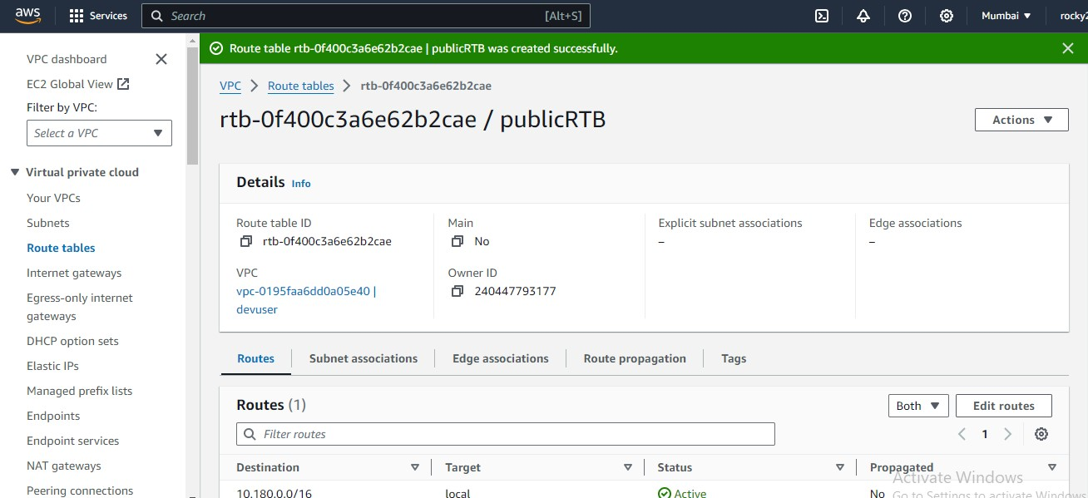

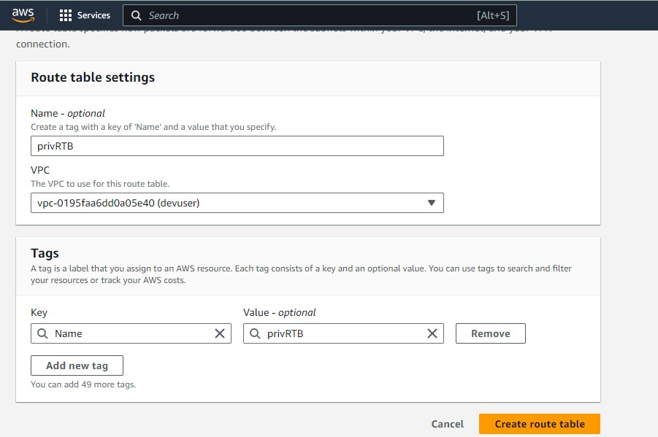

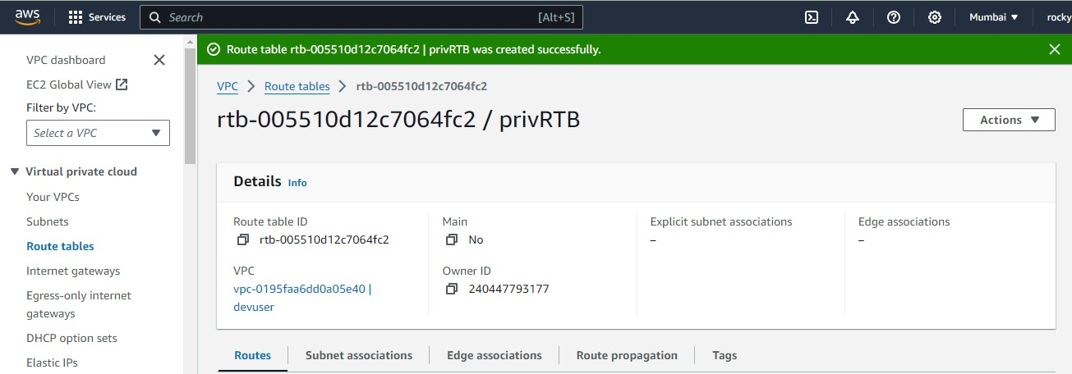

**17. Next part is edit submnet associations.**

**a. Select one by one like public first and second private to edit**

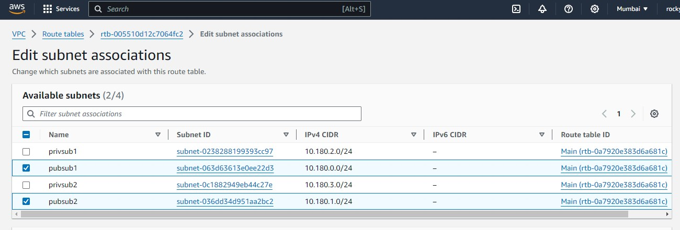

**18. By selecting option edit route it will be done and add required details shon below image.**

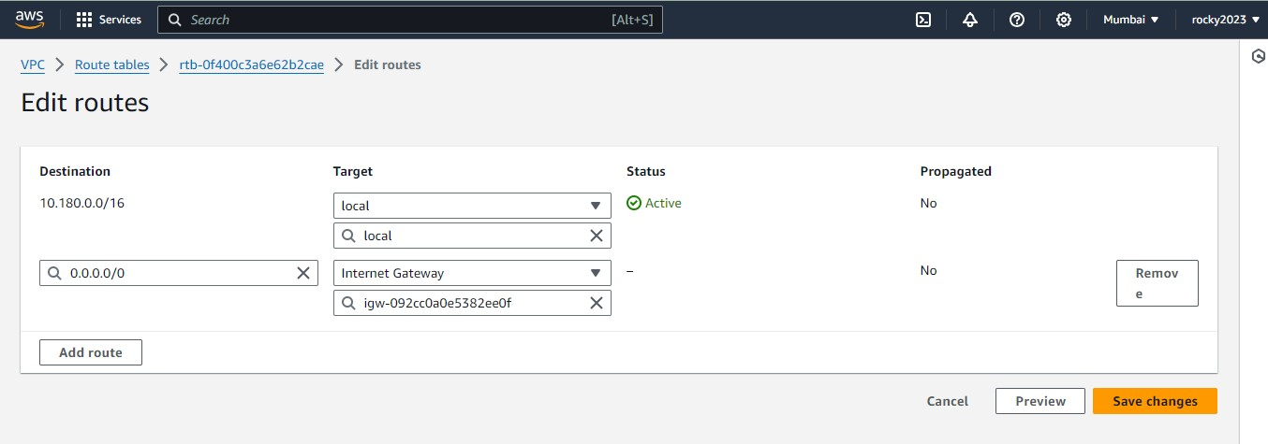

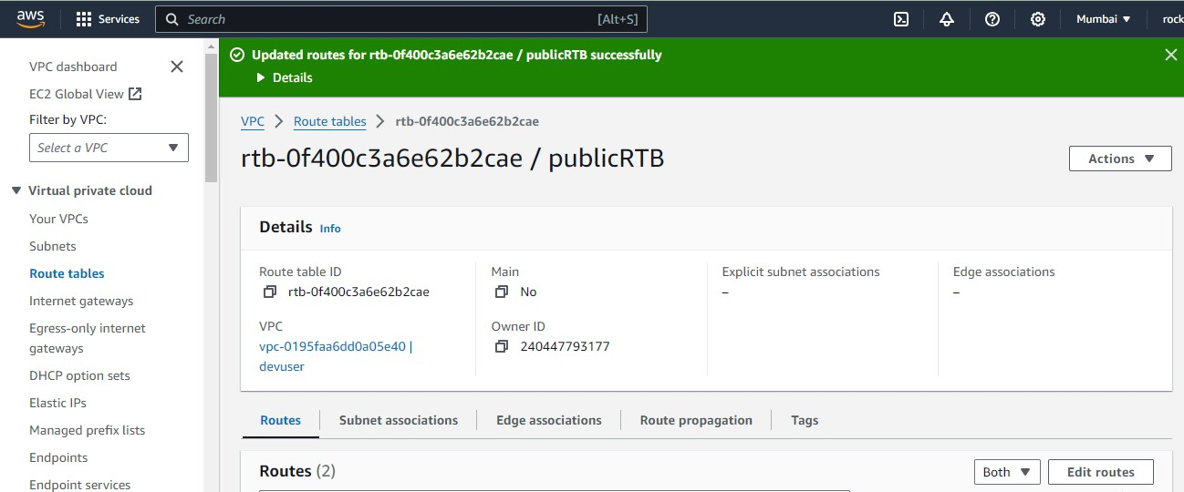

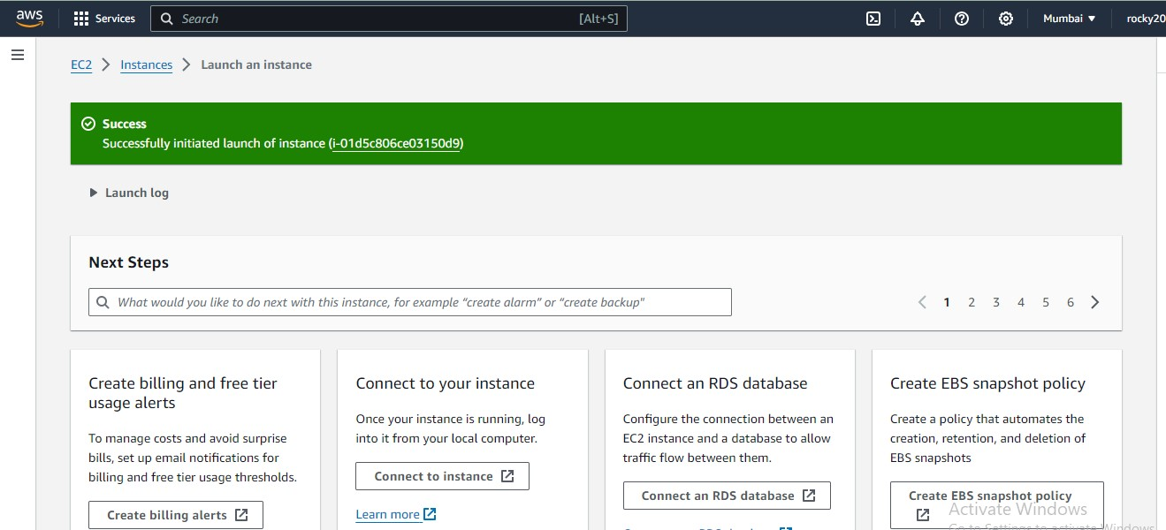**..**

**Both NaCl (Network Access Control Lists) and security groups are used in cloud computing environments to control network traffic, but they operate at different levels of the network stack.**

**1. *Network Access Control Lists (NaCl):\***

**- NaCl operates at the subnet level.**

**- It is a set of rules applied to subnets to control inbound and outbound traffic.**

**- Rules are stateless, meaning separate rules are needed for inbound and outbound traffic.**

**- Allows for more granular control over network traffic by specifying source and destination IP addresses, protocols, and ports.**

**2. *Security Groups:\***

**- Security groups operate at the instance level.**

**- They act as a virtual firewall for instances, controlling inbound and outbound traffic.**

**- Rules are stateful, meaning if an inbound rule allows traffic, the corresponding outbound traffic is automatically allowed and vice versa.**

**- Simplifies security management by allowing rules to be defined based on security group membership rather than specific IP addresses.**

**In summary, NaCl operates at the subnet level with stateless rules, while security groups operate at the instance level with stateful rules. Both are used to enhance network security in cloud environments, but they serve slightly different purposes and offer different levels of granularity and control.**